

**COBRA Cheat Sheet**

**Plans Subject to COBRA**

-Medical, dental and vision

-Health FSA – full and limited Health FSAs

-Employee Assistance Plan (EAP)

COBRA does not apply to health savings accounts (HSAs), long-term care policies, life insurance, disability insurance.

**Qualifying Events:**

A qualifying event is one that would cause an employee and/or dependent who had group health coverage to lose that coverage.

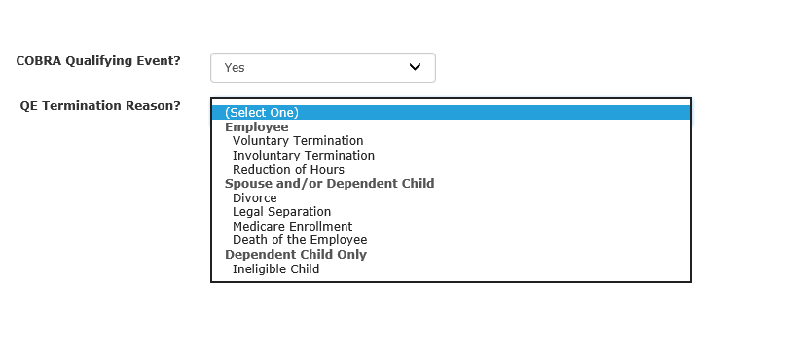*Below is a Benelogic screen shot that provides the Qualified Event Termination Reason when you select* ***“Yes”*** *to COBRA Qualifying Event:*

*Qualifying Events for Employees, Spouse and Dependents:*

* Voluntary or involuntary termination of employment for reasons other than gross misconduct.
* Reduction in the number of hours of employment if employee is no longer eligible for coverage. The reduction in hours is based on the **employer** moving the employee to an ineligible class that is not eligible for coverage – then the answer to COBRA would be “**yes”**.
* Death of an employee – answer “**yes**” for dependents.

*For spouse and dependents only – Answer “Yes” to a qualifying COBRA event:*

* Divorce or legal separation from employee.
* Death of covered employee.
* Employee entitlement to Medicare.

**Non-Qualifying Events**: Any time the employee is still eligible for coverage, COBRA is “**no**”.

* Dropping coverage during open enrollment is not a qualifying event. Answer COBRA “No” in Benelogic. (If during open enrollment there is a qualifying event such as a divorce or legal separation, this triggers COBRA rights for the spouse and the COBRA qualifying event should be answered “Yes” in Benelogic for the spouse).
* If the employee cancels coverage as the employee **voluntarily** moves to a part-time position, they would not be eligible to take COBRA.
* If an employee cancels coverage to go on spouse’s plan – this is not a qualifying event, and COBRA should be answered as **“no”.**
* If employee removes dependents (other than age 26) while the dependent are still eligible – COBRA should be answered as **“no”**.

**Qualifying Beneficiaries:**

Under COBRA, **qualified beneficiaries** have special rights that are not available otherwise. **To be a qualified beneficiary**, an individual must be covered under the plan the day before the qualifying event occurs and be one of the following:

• The covered employee

• The covered spouse

• A covered dependent

• A child born to, or placed for adoption with, the covered employee during a period of COBRA coverage.

Covered employees are:

• Any employee or former employee covered under the group health plan

**COBRA Continuation Coverage**

COBRA coverage must be identical to the coverage that is available to “similarly situated beneficiaries” (employees in the same class and/or category) under the plan that provided coverage to the qualified beneficiary. This is typically the same coverage the qualified beneficiary had the day before the qualifying event. This coverage cannot be reduced in any way or require proof of insurability.

Qualified beneficiaries must be given all the same open enrollment rights and options that are given to active employees. Any open enrollment materials that are provided to active employees must also be provided to qualified beneficiaries. If an employer modifies coverage for active employees, the same modifications apply to the corresponding COBRA continuation coverage (e.g., the employer changes insurance carriers or changes from an PPO to a HDHP).

**Duration of Coverage**

Generally, the **maximum coverage period** (the period that COBRA continuation coverage is available) is **18 months for employee qualifying events** (termination and reduction of hours) and **36 months for spouse and dependent qualifying events**.

If there is a qualified beneficiary on the plan becomes eligible for a disability extension (individual is determined to be disabled by the Social Security Administration before the 60th day of COBRA coverage), an 11-month extension begins at the conclusion of the original 18 months of coverage. (The qualified beneficiary would need to contact the COBRA administrator).

**Election Notice**

The Election Notice is given to qualified beneficiaries upon the occurrence of a qualifying event and includes information about the type of qualifying event, the date of qualifying event, the loss of coverage date, the election period expiration date, the type(s) of coverage available, the premium amounts and due dates, an explanation of separate election rights, the length of the continuation coverage period, the reasons why coverage may be terminated, and the name, address, and phone number of the plan administrator. This notice must be provided within 14 days of the qualifying event. If the employer and plan administrator are not the same, the employer has **30** days to notify the plan administrator that a qualifying event has occurred, and the plan administrator then has 14 days in which to provide the Election Notice.

Group health plans must allow qualified beneficiaries to pay for coverage monthly. To maintain coverage, qualified beneficiaries must make timely payments for all premiums due. **Timely payments** are payments **made within 45 days after the election date** (for the first payment) and **within 30 days** after the first day of each subsequent coverage period. The qualify beneficiary must make each payment within 30 days of the date a payment is due. (Example, if the employee has been paying COBRA premiums, premium is due the first of the month (May 1) of coverage, but no later than 30 days (May 30) or coverage will be terminated.

**Paying for COBRA Coverage**

In the absence of any severance or other agreement to the contrary, qualified beneficiaries must pay for COBRA continuation coverage. A group health plan may charge 102 percent of the applicable premium during standard COBRA coverage periods and 150 percent of the applicable premium during an 11-month disability period. Payment is made to the COBRA administrator.

**Notice of Early Termination**

Whenever a qualified beneficiary loses COBRA continuation coverage for any reason other than reaching the end of the maximum coverage period (18 or 36 months, depending on the qualifying event), the COBRA administrator will provide a notice that identifies the date of coverage termination and the reason for the loss of coverage.

About this Cheat Sheet

**We designed this Cheat Sheet to be an easy-to-use reference tool for the most important aspects of**

**COBRA. The rules and regulations governing COBRA continuation coverage are extensive and this Cheat**

**Sheet does not contain all the information about any part of COBRA law. It is simply a handy tool when you need a quick reminder of COBRA and its qualifying events.**

**6-2021**